

Bootstrap is an open source toolkit for developing with HTML, CSS, and JS. Quickly prototype your ideas or build your entire app with our Sass variables and mixins, responsive grid system, extensive prebuilt components, and powerful plugins built on jQuery. Unlike many web frameworks, it concerns itself with front-end development only.

Bootstrap, originally named Twitter Blueprint, was developed by Mark Otto and Jacob Thornton at Twitter as a framework to encourage consistency across internal tools. Before Bootstrap, various libraries were used for interface development, which led to inconsistencies and a high maintenance burden. According to Twitter developer Mark Otto:

"A super small group of developers and I got together to design and build a new internal tool and saw an opportunity to do something more. Through that process, we saw ourselves build something much more substantial than another internal tool. Months later, we ended up with an early version of Bootstrap as a way to document and share common design patterns and assets within the company."

After a few months of development by a small group, many developers at Twitter began to contribute to the project as a part of Hack Week, a hackathon-style week for the Twitter development team. It was renamed from Twitter Blueprint to Bootstrap, and released as an open source project on August 19, 2011. It has continued to be maintained by Mark Otto, Jacob Thornton, and a small group of core developers, as well as a large community of contributors.

On January 31, 2012, Bootstrap 2 was released, which added a twelve-column responsive grid layout system, inbuilt support for Glyph icons, several new components, as well as changes to many of the existing components.

On August 19, 2013, Bootstrap 3 was released, which redesigned components to use flat design, and a mobile first approach.

On October 29, 2014, Mark Otto announced that Bootstrap 4 was in development. The first alpha version of Bootstrap 4 was released on August 19, 2015. The first beta version was released on 10 August 2017.

**Advantages of Bootstrap**

* **Easy to use:** Anybody with just basic knowledge of HTML and CSS can start using Bootstrap 4
* **Responsive features:** Bootstrap's responsive CSS adjusts to phones, tablets, and desktops
* **Mobile-first approach:** In Bootstrap 4, mobile-first styles are part of the core framework
* **Browser compatibility:** Bootstrap 4 is compatible with all modern browsers (Chrome, Firefox, Internet Explorer 10+, Safari, and Opera)

**How To Use Bootstrap**

There are two ways to start using Bootstrap 4 on your own web site.

You can:

* Include Bootstrap 4 from a CDN

<!-- Latest compiled and minified CSS -->  
<link rel="stylesheet"href="https://maxcdn.bootstrapcdn.com/bootstrap/4.0.0/css/bootstrap.min.css">  
  
<!-- jQuery library -->  
<script src="https://ajax.googleapis.com/ajax/libs/jquery/3.3.1/jquery.min.js"></script>  
  
<!-- Popper JS -->  
<script src="https://cdnjs.cloudflare.com/ajax/libs/popper.js/1.12.9/umd/popper.min.js"></script>  
  
<!-- Latest compiled JavaScript -->  
<script src="https://maxcdn.bootstrapcdn.com/bootstrap/4.0.0/js/bootstrap.min.js"></script>

* Download Bootstrap 4 from getbootstrap.com

**Components of Bootstrap**

**1) Bootstrap Grid:** Bootstrap's grid system is built with flexbox and allows up to 12 columns across the page.

If you do not want to use all 12 columns individually, you can group the columns together to create wider columns:

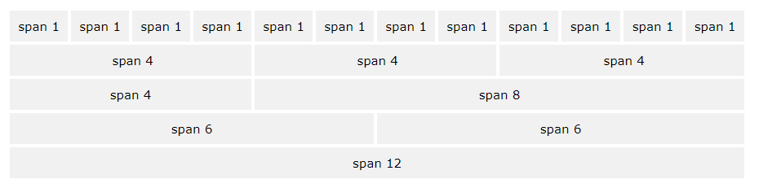

The grid system is responsive, and the columns will re-arrange automatically depending on the screen size.

Make sure that the sum adds up to 12 or fewer (it is not required that you use all 12 available columns).

Grid Classes

The Bootstrap grid system has five classes:

* .col- (extra small devices - screen width less than 576px)
* .col-sm- (small devices - screen width equal to or greater than 576px)
* .col-md- (medium devices - screen width equal to or greater than 768px)
* .col-lg- (large devices - screen width equal to or greater than 992px)
* .col-xl- (xlarge devices - screen width equal to or greater than 1200px)

The classes above can be combined to create more dynamic and flexible layouts.

**Tip:** Each class scales up, so if you wish to set the same widths for sm and md, you only need to specify sm.

2) Bootstrap Typography

Bootstrap 4(current version of bootstrap) uses a default font-size of 16px, and its line-height is 1.5.

The default font-family is "Helvetica Neue", Helvetica, Arial, sans-serif.

In addition, all <p> elements have margin-top: 0 and margin-bottom: 1rem (16px by default).

## <h1> - <h6>

Bootstrap 4 styles HTML headings (<h1> to <h6>)  with a bolder font-weight and an increased font-size:

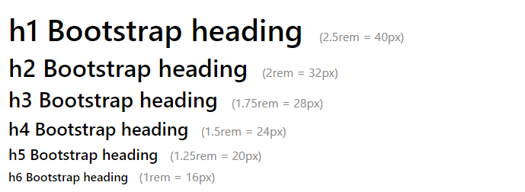

Display Headings

Display headings are used to stand out more than normal headings (larger font-size and lighter font-weight), and there are four classes to choose from: .display-1, .display-2, .display-3, .display-4

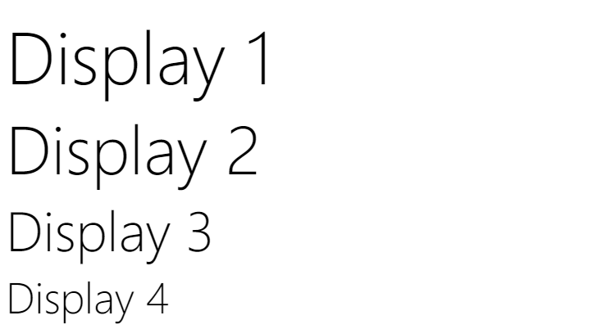

<small>

In Bootstrap 4 the HTML <small> element is used to create a lighter, secondary text in any heading:

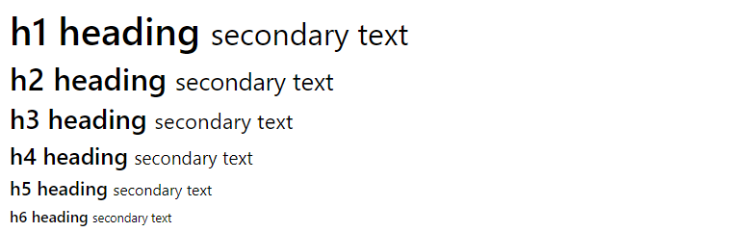

**3) Bootstrap Colours**

Text Colours

Bootstrap 4 has some contextual classes that can be used to provide "meaning through colours".

The classes for text colours are:.text-muted, .text-primary, .text-success, .text-info, .text-warning, .text-danger, .text-secondary, .text-white, .text-dark and .text-light:

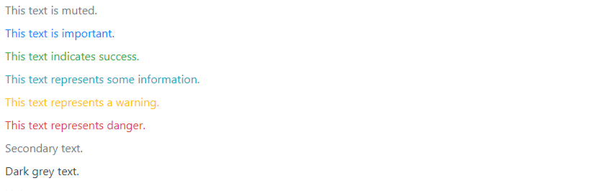

Background Colours

The classes for background colours are: .bg-primary, .bg-success, .bg-info, .bg-warning, .bg-danger, .bg-secondary, .bg-dark and .bg-light.

Note that background colours do not set the text color, so in some cases you'll want to use them together with a .text-* class.

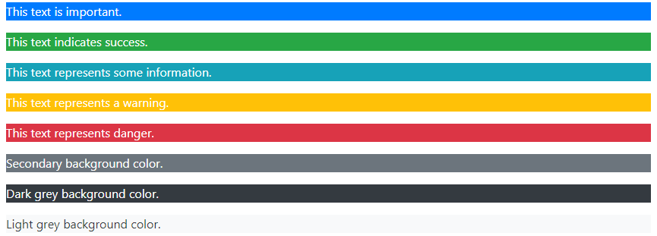

4) **Bootstrap Tables**

Basic Table

A basic Bootstrap 4 table has a light padding and horizontal dividers.

The “.table” class adds basic styling to a table:

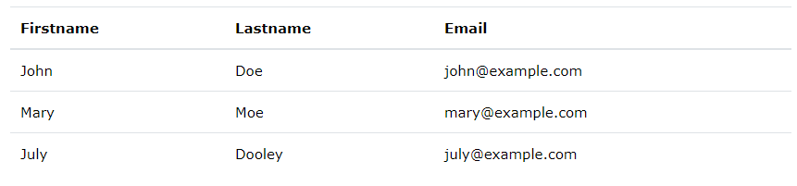

Striped Rows

The .table-striped class adds zebra-stripes to a table:

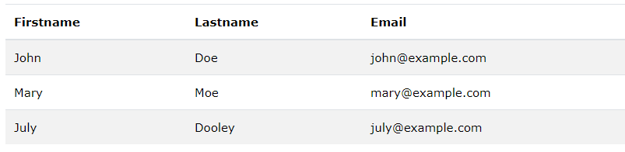

Bordered Table

The .table-bordered class adds borders on all sides of the table and cells:

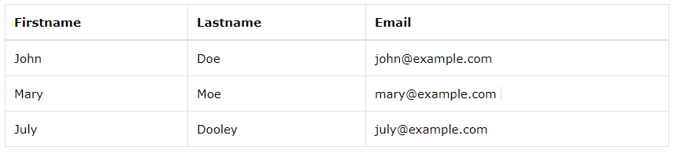

5) **Bootstrap Images**

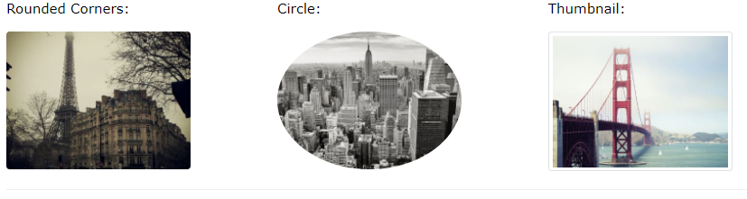

Rounded Corners

The .rounded class adds rounded corners to an image:

<img src="cinqueterre.jpg" class="rounded" alt="Cinque Terre">

## Circle

The .rounded-circle class shapes the image to a circle:

<img src="cinqueterre.jpg" class="rounded-circle" alt="Cinque Terre">

Thumbnail

The .img-thumbnail class shapes the image to a thumbnail (bordered):

<img src="cinqueterre.jpg" class="img-thumbnail" alt="Cinque Terre">

Responsive Images

Images come in all sizes. So do screens. Responsive images automatically adjust to fit the size of the screen.

Create responsive images by adding an .img-fluid class to the <img> tag. The image will then scale nicely to the parent element.

The .img-fluid class applies max-width: 100%; and height: auto; to the image:

<img class="img-fluid" src="img_chania.jpg" alt="Chania">

## Aligning Images

Float an image to the right with the .float-right class or to the left with .float-left:



<img src="paris.jpg" class="float-left">   
<img src="paris.jpg" class="float-right">

6) Bootstrap Cards

## Cards

A card in Bootstrap 4 is a bordered box with some padding around its content. It includes options for headers, footers, content, colours, etc.

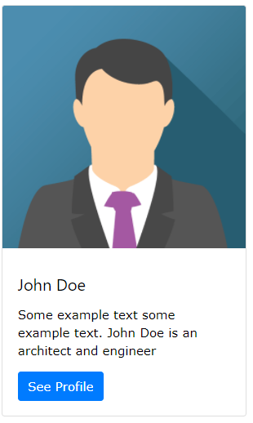

Basic Card

A basic card is created with the .card class, and content inside the card has a .card-body class:



<div class="card">  
  <div class="card-body">Basic card</div>  
</div>

## Header and Footer

## 

## The .card-header class adds a heading to the card and the .card-footer class adds a footer to the card:

## <div class="card">   <div class="card-header">Header</div>   <div class="card-body">Content</div>    <div class="card-footer">Footer</div> </div>